SIMATS ENGINEERING
ASSESSMENT TOOL 1

COURSE CODE: CSA1442 COURSE NAME: Compiler Design for Higher
Level Processing

COURSE OUTCOME COVERED

CO2: Construct top-down and bottom up parsers using CFG for parsing conflicts and error recovery for efficient syntax tree generation. (BL3)

Assessment Tool Weightage: 40%

QUESTIONS:4 Total Marks:50
Annexure A

DESIGN TASK

Code of Conduct:

I ___Keerthana.G (192521446)___ (Name / Reg No) certify that this submission is my original work and that I have adhered to the guidelines specified for this assessment.
I understand that any violation of academic integrity rules will result in disciplinary action.

Signature of the student:

Course Faculty

Annexure A

DESIGN TASK
Q1. Predictive Parser Design (Application Level)
Grammar:
E → T E'
E' → + T E' | ε
T → F T'
T' → * F T' | ε
F → (E) | id

Answer:

i). AIM :

To construct an LL(1) predictive parsing table for the given grammar, calculate FIRST and FOLLOW sets, and demonstrate step-by-step parsing of the input string id + id * id.

ii).GIVEN GRAMMAR

E -> T E'
E' -> + T E' | epsilon
T -> F T'
T' -> * F T' | epsilon
F -> ( E ) | id
Here, epsilon represents the empty string, and $ represents the end of input.

iii).REMOVAL OF LEFT RECURSION

The given grammar does not contain left recursion because no non-terminal derives a string beginning with itself.
Therefore, no left-recursion elimination is required. The grammar is already suitable for LL(1) parsing.

iv).FIRST SETS

FIRST(E):
E -> T E'
FIRST(E) = FIRST(T) = FIRST(F)
FIRST(E) = { (, id }

FIRST(E'):
E' -> + T E' | epsilon
FIRST(E') = { +, epsilon }
FIRST(T):
T -> F T'
FIRST(T) = FIRST(F)
FIRST(T) = { (, id }

FIRST(T'):
T' -> * F T' | epsilon
FIRST(T') = { *, epsilon }

FIRST(F):
F -> ( E ) | id
FIRST(F) = { (, id }

FIRST SETS SUMMARY

Non-terminal | FIRST Set
E | { (, id }
E’ | { +, epsilon }
T | { (, id }
T’ | { *, epsilon }
F | { (, id }

v).FOLLOW SETS

FOLLOW(E):
E is the start symbol, so $ is included. E is also followed by ) in F -> ( E ).
FOLLOW(E) = { ), $ }

FOLLOW(E'):
From E -> T E', E' is at the end. Therefore, FOLLOW(E') = FOLLOW(E).
FOLLOW(E') = { ), $ }

FOLLOW(T):
From E -> T E', FIRST(E') gives +. Since E' can derive epsilon, FOLLOW(E) is also included.
FOLLOW(T) = { +, ), $ }

FOLLOW(T'):
From T -> F T', T' is at the end.
FOLLOW(T') = FOLLOW(T)
FOLLOW(T') = { +, ), $ }

FOLLOW(F):
From T -> F T', FIRST(T') gives *. Since T' can derive epsilon, FOLLOW(T) is also included.
FOLLOW(F) = { *, +, ), $ }

FOLLOW SETS SUMMARY

Non-terminal | FOLLOW Set
E | { ), $ }
E’ | { ), $ }
T | { +, ), $ }
T’ | { +, ), $ }
F | { *, +, ), $ }

vi).STEP BY STEP PREDICTIVE PARSING

The parsing table is constructed using FIRST sets. If a production can derive epsilon, it is entered in the columns corresponding to the FOLLOW set of that non-terminal.

LL(1) PARSING TABLE

Input: id + id * id

Step | Stack (Top at Right) | Input Buffer | Action
1 | $ E | id + id * id $ | E → T E'
2 | $ E' T | id + id * id $ | T → F T'
3 | $ E' T' F | id + id * id $ | F → id
4 | $ E' T' id | id + id * id $ | Match id
5 | $ E' T' | + id * id $ | T' → ε
6 | $ E' | + id * id $ | E' → + T E'
7 | $ E' T + | + id * id $ | Match +
8 | $ E' T | id * id $ | T → F T'
9 | $ E' T' F | id * id $ | F → id
10 | $ E' T' id | id * id $ | Match id
11 | $ E' T' | * id $ | T' → * F T'
12 | $ E' T' F * | * id $ | Match *
13 | $ E' T' F | id $ | F → id
14 | $ E' T' id | id $ | Match id
15 | $ E' T' | $ | T' → ε
16 | $ E' | $ | E' → ε
17 | $ | $ | ACCEPT

vii).PROGRAM: IMPLEMENTATION OF LL(1) PREDICTIVE PARSER IN C

#include <stdio.h>
#include <string.h>
char input[100][10];
int n, pos = 0;
char stack[100][10];
int top = -1;

void push(const char *s) {
strcpy(stack[++top], s);
}

void print_state(int step, const char *action) {
int i;
printf("%-5d | ", step);
for (i = 0; i <= top; i++)
printf("%s ", stack[i]);
printf("\t| ");
for (i = pos; i < n; i++)
printf("%s ", input[i]);
printf("\t| %s\n", action);
}

int is_terminal(const char *s) {
return strcmp(s, "id") == 0 || strcmp(s, "+") == 0 ||
strcmp(s, "*") == 0 || strcmp(s, "(") == 0 ||
strcmp(s, ")") == 0 || strcmp(s, "$") == 0;
}

int main(void) {
char expr[100];
int i, step = 1;
char symbol[10], action[100];

printf("LL(1) Predictive Parser\n");
printf("Grammar:\n");
printf("E -> T E'\n");
printf("E' -> + T E' | epsilon\n");
printf("T -> F T'\n");
printf("T' -> * F T' | epsilon\n");
printf("F -> ( E ) | id\n\n");

printf("Enter tokens separated by spaces (example: id + id * id):\n");
if (!fgets(expr, sizeof(expr), stdin))
return 1;

n = 0;
char *token = strtok(expr, " \t\r\n");
while (token != NULL && n < 98) {
if (strcmp(token, "id") != 0 && strcmp(token, "+") != 0 &&
strcmp(token, "*") != 0 && strcmp(token, "(") != 0 &&
strcmp(token, ")") != 0) {
printf("Invalid token: %s\nString Rejected\n", token);
return 0;
}
strcpy(input[n++], token);
token = strtok(NULL, " \t\r\n");
}
strcpy(input[n++], "$");

push("$");
push("E");

printf("\nStep | Stack (top at right)\t| Input Buffer\t\t| Action\n");
printf("--------------------------------------------------------------------------\n");

while (top >= 0) {
char current[10];
strcpy(current, stack[top]);

if (strcmp(current, "$") == 0 && strcmp(input[pos], "$") == 0) {
print_state(step, "ACCEPT");
printf("\nResult: String Accepted\n");
return 0;
}

if (is_terminal(current)) {
if (strcmp(current, input[pos]) == 0) {
sprintf(action, "Match %s", current);
print_state(step++, action);
top--;
pos++;
} else {
print_state(step, "ERROR: terminal mismatch");
printf("\nResult: String Rejected\n");
return 0;
}
} else {
action[0] = '\0';

if (strcmp(current, "E") == 0 &&
(strcmp(input[pos], "id") == 0 || strcmp(input[pos], "(") == 0)) {
strcpy(action, "E -> T E'");
print_state(step++, action);
top--;
push("E'");
push("T");
} else if (strcmp(current, "E'") == 0 && strcmp(input[pos], "+") == 0) {
strcpy(action, "E' -> + T E'");
print_state(step++, action);
top--;
push("E'");
push("T");
push("+");
} else if (strcmp(current, "E'") == 0 &&
(strcmp(input[pos], ")") == 0 || strcmp(input[pos], "$") == 0)) {
strcpy(action, "E' -> epsilon");
print_state(step++, action);
top--;
} else if (strcmp(current, "T") == 0 &&
(strcmp(input[pos], "id") == 0 || strcmp(input[pos], "(") == 0)) {
strcpy(action, "T -> F T'");
print_state(step++, action);
top--;
push("T'");
push("F");
} else if (strcmp(current, "T'") == 0 && strcmp(input[pos], "*") == 0) {
strcpy(action, "T' -> * F T'");
print_state(step++, action);
top--;
push("T'");
push("F");
push("*");
} else if (strcmp(current, "T'") == 0 &&
(strcmp(input[pos], "+") == 0 || strcmp(input[pos], ")") == 0 ||
strcmp(input[pos], "$") == 0)) {
strcpy(action, "T' -> epsilon");
print_state(step++, action);
top--;
} else if (strcmp(current, "F") == 0 && strcmp(input[pos], "id") == 0) {
strcpy(action, "F -> id");
print_state(step++, action);
top--;
push("id");
} else if (strcmp(current, "F") == 0 && strcmp(input[pos], "(") == 0) {
strcpy(action, "F -> ( E )");
print_state(step++, action);
top--;
push(")");
push("E");
push("(");
} else {
print_state(step, "ERROR: no table entry");
printf("\nResult: String Rejected\n");
return 0;
}
}
}

printf("\nResult: String Rejected\n");
return 0;
}

viii). EXECUTE THE PROGRAM WITH VALID AND INVALID INPUT STRINGS AND DISPLAY THE OUTPUT.

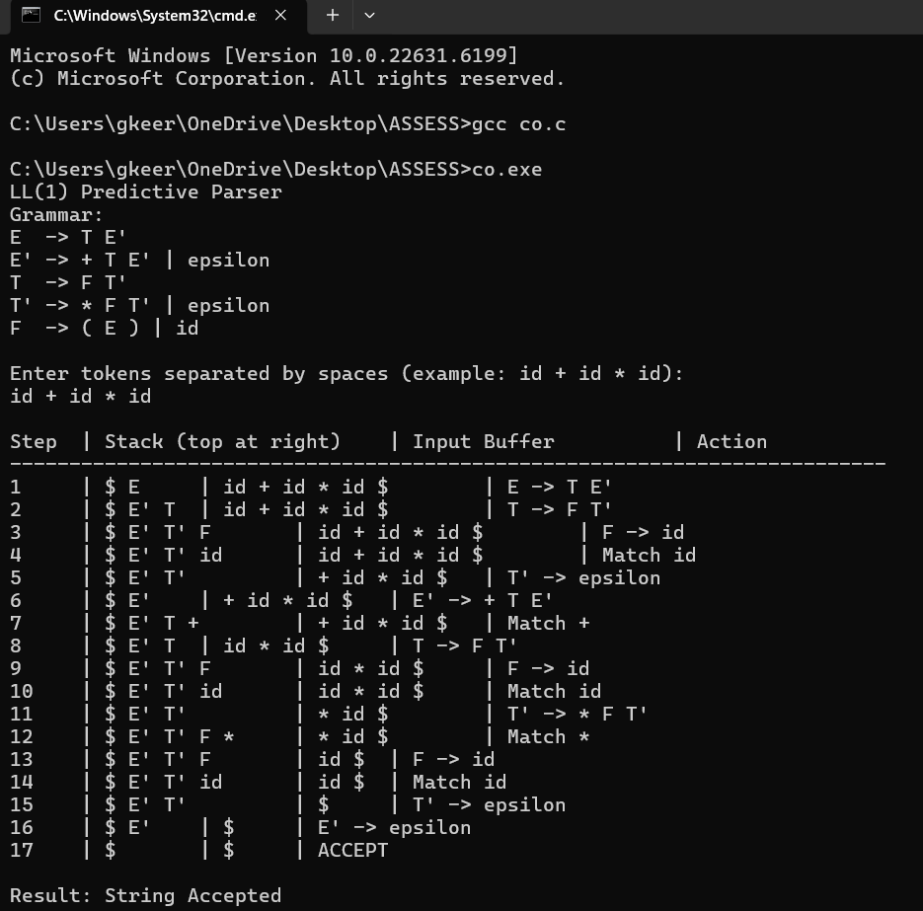

Q2. Shift-Reduce Parsing (Application Level)
Grammar:
E → E + E
E → E * E
E → id

Answer :

i).AIM

To implement shift-reduce parsing for the given grammar and demonstrate the step-by-step parsing of the input string id + id * id using stack contents, input buffer, and parsing actions. Operator precedence is used to give * higher precedence than +.

ii). GIVEN GRAMMAR

E → E + E
E → E * E
E → id
Here, id represents an identifier, and $ represents the end of input.

iii). SHIFT-REDUCE PARSING

Shift-reduce parsing is a bottom-up parsing technique that constructs the parse tree from the input string towards the start symbol.
It uses the following operations:
- Shift: Move the next input symbol onto the stack.
- Reduce: Replace the symbols on the stack that match the right-hand side of a production with its left-hand side.
- Accept: Accept the input when the stack contains the start symbol E and the input is $.
- Error: Reject the input if no valid parsing action is possible.

iv). OPERATOR PRECEDENCE

The given grammar is ambiguous. Therefore, operator precedence is used to resolve conflicts.
- Multiplication (*) has higher precedence than addition (+).
- Addition and multiplication are evaluated from left to right when operators have equal precedence.
For the input id + id * id, multiplication is reduced before addition.

v). STEP-BY-STEP SHIFT-REDUCE PARSING

Input: id + id * id $

Step | Stack | Input Buffer | Action
1 | $ | id + id * id $ | Shift id
2 | $ id | + id * id $ | Reduce E → id
3 | $ E | + id * id $ | Shift +
4 | $ E + | id * id $ | Shift id
5 | $ E + id | * id $ | Reduce E → id
6 | $ E + E | * id $ | Shift *
7 | $ E + E * | id $ | Shift id
8 | $ E + E * id | $ | Reduce E → id
9 | $ E + E * E | $ | Reduce E → E * E
10 | $ E + E | $ | Reduce E → E + E
11 | $ E | $ | Accept

vi). C PROGRAM: IMPLEMENTATION OF SHIFT-REDUCE PARSER

#include <stdio.h>
#include <string.h>

char stack[100][10], input[100][10];
int top = 0, n = 0, pos = 0, step = 1;

void display(char action[]) {
int i;
printf("%-5d | ", step++);
for (i = 0; i <= top; i++)
printf("%s ", stack[i]);
printf("\t| ");
for (i = pos; i < n; i++)
printf("%s ", input[i]);
printf("\t| %s\n", action);
}

int main() {
char expr[200], action[50];
char *token;
int i;

printf("SHIFT-REDUCE PARSER\n");
printf("Grammar:\n");
printf("E -> E + E\n");
printf("E -> E * E\n");
printf("E -> id\n");

printf("\nEnter tokens separated by spaces:\n");
if (fgets(expr, sizeof(expr), stdin) == NULL)
return 1;

token = strtok(expr, " \t\r\n");

while (token != NULL && n < 98) {
if (strcmp(token, "id") != 0 &&
strcmp(token, "+") != 0 &&
strcmp(token, "*") != 0) {
printf("Result: String Rejected\n");
return 0;
}

strcpy(input[n++], token);
token = strtok(NULL, " \t\r\n");
}

if (n == 0) {
printf("Result: String Rejected\n");
return 0;
}

strcpy(input[n++], "$");
strcpy(stack[0], "$");

printf("\nStep | Stack\t\t| Input Buffer\t| Action\n");
printf("----------------------------------------------------------\n");

while (1) {
/* Reduce E -> id */
if (top >= 1 && strcmp(stack[top], "id") == 0) {
strcpy(stack[top], "E");
display("Reduce E -> id");
continue;
}

/* Reduce E -> E * E */
if (top >= 3 &&
strcmp(stack[top-2], "E") == 0 &&
strcmp(stack[top-1], "*") == 0 &&
strcmp(stack[top], "E") == 0) {
strcpy(stack[top-2], "E");
top -= 2;
display("Reduce E -> E * E");
continue;
}

/* Reduce E -> E + E, unless next is * */
if (top >= 3 &&
strcmp(stack[top-2], "E") == 0 &&
strcmp(stack[top-1], "+") == 0 &&
strcmp(stack[top], "E") == 0 &&
strcmp(input[pos], "*") != 0) {
strcpy(stack[top-2], "E");
top -= 2;
display("Reduce E -> E + E");
continue;
}

/* Accept or reject at end of input */
if (strcmp(input[pos], "$") == 0) {
if (top == 1 && strcmp(stack[1], "E") == 0) {
display("ACCEPT");
printf("\nResult: String Accepted\n");
} else {
display("ERROR");
printf("\nResult: String Rejected\n");
}
break;
}

if (top >= 98) {
printf("\nResult: String Rejected\n");
break;
}

/* Shift next input token */
strcpy(stack[++top], input[pos]);
sprintf(action, "Shift %s", input[pos]);
pos++;
display(action);
}

return 0;
}

vii). EXECUTION OF THE PROGRAM

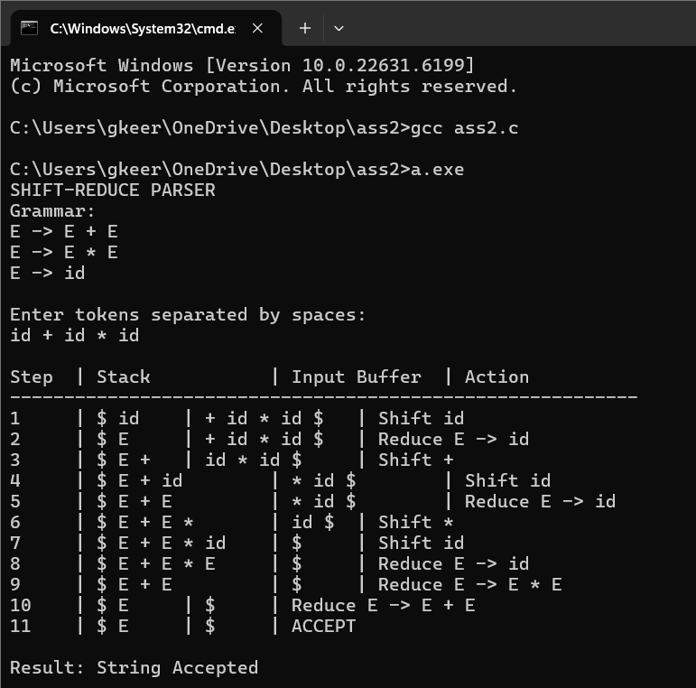

Q3.Construct the LR parsing tables for the given grammar and perform a detailed comparison of different LR parsing techniques (SLR, LALR, and CLR), highlighting their construction steps, state transitions, table sizes, and any conflicts encountered.

S → L = R | R
L → * R | id
R → L

Given Grammar

S → L = R | R
L → * R | id
R → L
Augmented Grammar:
S' → S
Terminals: id, *, =, $
Non-terminals: S, L, R

(i) CLR (Canonical LR) Design

Step 1: FIRST Sets

Non-terminal | FIRST Set
FIRST(S) | { *, id }
FIRST(L) | { *, id }
FIRST(R) | { *, id }

Step 2: FOLLOW Sets

Non-terminal | FOLLOW Set
FOLLOW(S) | { $ }
FOLLOW(L) | { =, $ }
FOLLOW(R) | { =, $ }

Step 3: Canonical Collection of LR(1) Items

I0
S' → · S, $
S → · L = R, $
S → · R, $
L → · * R, =
L → · id, =
R → · L, $

Transitions:
S → I1, L → I2, R → I3, * → I4, id → I5
I1
S' → S ·, $
I2
S → L · = R, $
R → L ·, $

Transition: = → I6
I3
S → R ·, $
I4
L → * · R, =
R → · L, =
L → · * R, =
L → · id, =

Transitions:
R → I7, L → I8, * → I4, id → I5
I5
L → id ·, =
I6
S → L = · R, $
R → · L, $
L → · * R, $
L → · id, $

Transitions:
R → I9, L → I3, * → I4, id → I10
I7
L → * R ·, =
I8
R → L ·, =
I9
S → L = R ·, $
I10
L → id ·, $

Step 4: CLR Parsing Table

Production numbers:
(1) S → L = R
(2) S → R
(3) L → * R
(4) L → id
(5) R → L

State | id | * | = | $ | S | L | R
0 | S5 | S4 | — | — | 1 | 2 | 3
1 | — | — | — | Accept | — | — | —
2 | — | — | S6 | R5 | — | — | —
3 | — | — | — | R2 | — | — | —
4 | S5 | S4 | — | — | — | 8 | 7
5 | — | — | R4 | — | — | — | —
6 | S10 | S4 | — | — | — | 3 | 9
7 | — | — | R3 | — | — | — | —
8 | — | — | R5 | — | — | — | —
9 | — | — | — | R1 | — | — | —
10 | — | — | — | R4 | — | — | —

S = Shift, R = Reduce, Accept = Input accepted, — = Error.

(ii) SLR Parser Design

Step 1: FOLLOW Sets

FOLLOW(S) = { $ }
FOLLOW(L) = { =, $ }
FOLLOW(R) = { =, $ }
Step 2: SLR Parsing Table

State | id | * | = | $ | S | L | R
0 | S5 | S4 | — | — | 1 | 2 | 3
1 | — | — | — | Accept | — | — | —
2 | — | — | S6 | R5 | — | — | —
3 | — | — | — | R2 | — | — | —
4 | S5 | S4 | — | — | — | 8 | 7
5 | — | — | R4 | R4 | — | — | —
6 | S5 | S4 | — | — | — | 2 | 9
7 | — | — | R3 | R3 | — | — | —
8 | — | — | R5 | R5 | — | — | —
9 | — | — | — | R1 | — | — | —

Step 3: Conflict Analysis
The grammar is not SLR(1) because state 2 contains both:
S → L · = R
R → L ·
The first item requires shifting =, while the second item requires reducing by R → L on FOLLOW(R) = { =, $ }.
Therefore, a shift-reduce conflict occurs on = in state 2.
The same conflict occurs in the corresponding state reached after reading * R.
Hence, the grammar is not SLR(1).

(iii) LALR Parser Design

Step 1: Merge Compatible CLR States

LALR construction combines CLR states having identical LR(0) cores.
For this grammar, the compatible states include:
- I5 and I10: L → id ·
- I7 and the corresponding state containing L → * R · with lookahead $
- I8 and the corresponding state containing R → L · with lookahead $
After merging, lookaheads are combined in the same state.
The merged states reduce the number of states compared with CLR.

Step 2: LALR Parsing Table

The LALR table uses the merged CLR states. The reductions are entered only for their respective lookahead symbols.
The main advantage of LALR is that it provides fewer states than CLR while retaining more parsing power than SLR in many grammars.
For this grammar, merging compatible states does not remove the SLR shift-reduce conflict on =. Therefore, this grammar is not LALR(1).

(iv) Parsing Demonstration

Input String: id = * id $
Use the grammar:
(1) S → L = R
(2) S → R
(3) L → * R
(4) L → id
(5) R → L

The input string id = * id is valid.

Step | Stack | Input Buffer | Action
1 | 0 | id = * id $ | Shift id
2 | 0 id 5 | = * id $ | Reduce L → id
3 | 0 L 2 | = * id $ | Shift =
4 | 0 L 2 = 6 | * id $ | Shift *
5 | 0 L 2 = 6 * 4 | id $ | Shift id
6 | 0 L 2 = 6 * 4 id 5 | $ | Reduce L → id
7 | 0 L 2 = 6 * 4 L 8 | $ | Reduce R → L
8 | 0 L 2 = 6 * 4 R 7 | $ | Reduce L → * R
9 | 0 L 2 = 6 R 9 | $ | Reduce S → L = R
10 | 0 S 1 | $ | Accept

Result: String Accepted.

Comparison of SLR, LALR, and CLR

Feature | SLR | LALR | CLR
Full Form | Simple LR | Look-Ahead LR | Canonical LR
Items Used | LR(0) items | Merged LR(1) items | LR(1) items
Lookahead | FOLLOW sets | Individual LR(1) lookaheads merged by core | Individual LR(1) lookaheads
Number of States | Usually fewer | Fewer than or equal to CLR | Usually more
Parsing Power | Lowest of the three | Greater than or equal to SLR in general | Highest of the three
Table Size | Small | Medium | Large
Conflict Handling | More conflicts may occur | Fewer conflicts than SLR in general | Most precise lookahead handling
Construction | Simple | Moderate | Complex
This Grammar | Not SLR(1) | Not LALR(1) | CLR(1) construction must be checked for conflicts

V) CLR Parser Implementation in C

#include <stdio.h>
#include <string.h>

char input[100];
int pos = 0;

int S();
int L();
int R();

int match(char c)
{
if (input[pos] == c)
{
pos++;
return 1;
}
return 0;
}

int L()
{
if (match('*'))
return R();

if (match('i'))
{
if (match('d'))
return 1;
}

return 0;
}

int R()
{
return L();
}

int S()
{
int save = pos;

if (L() && match('=') && R())
return 1;

pos = save;

if (R())
return 1;

return 0;
}

int main()
{
printf("Enter input string (use id for identifier): ");
scanf("%99s", input);

if (S() && input[pos] == '\0')
printf("String Accepted\n");
else
printf("String Rejected\n");

return 0;
}

VI) CLR PARSER IMPLEMENTATION IN C WITH OUTPUT SCREENSHOT
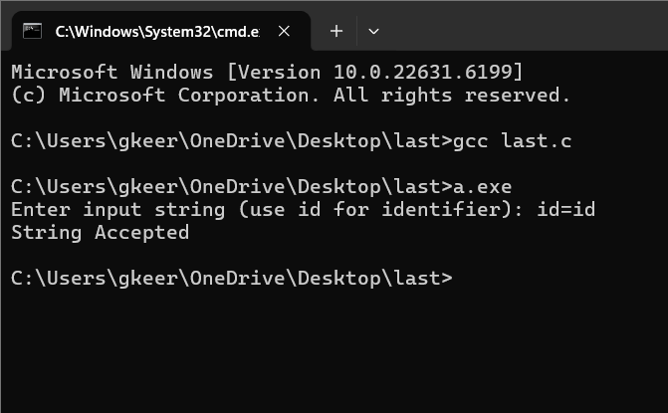

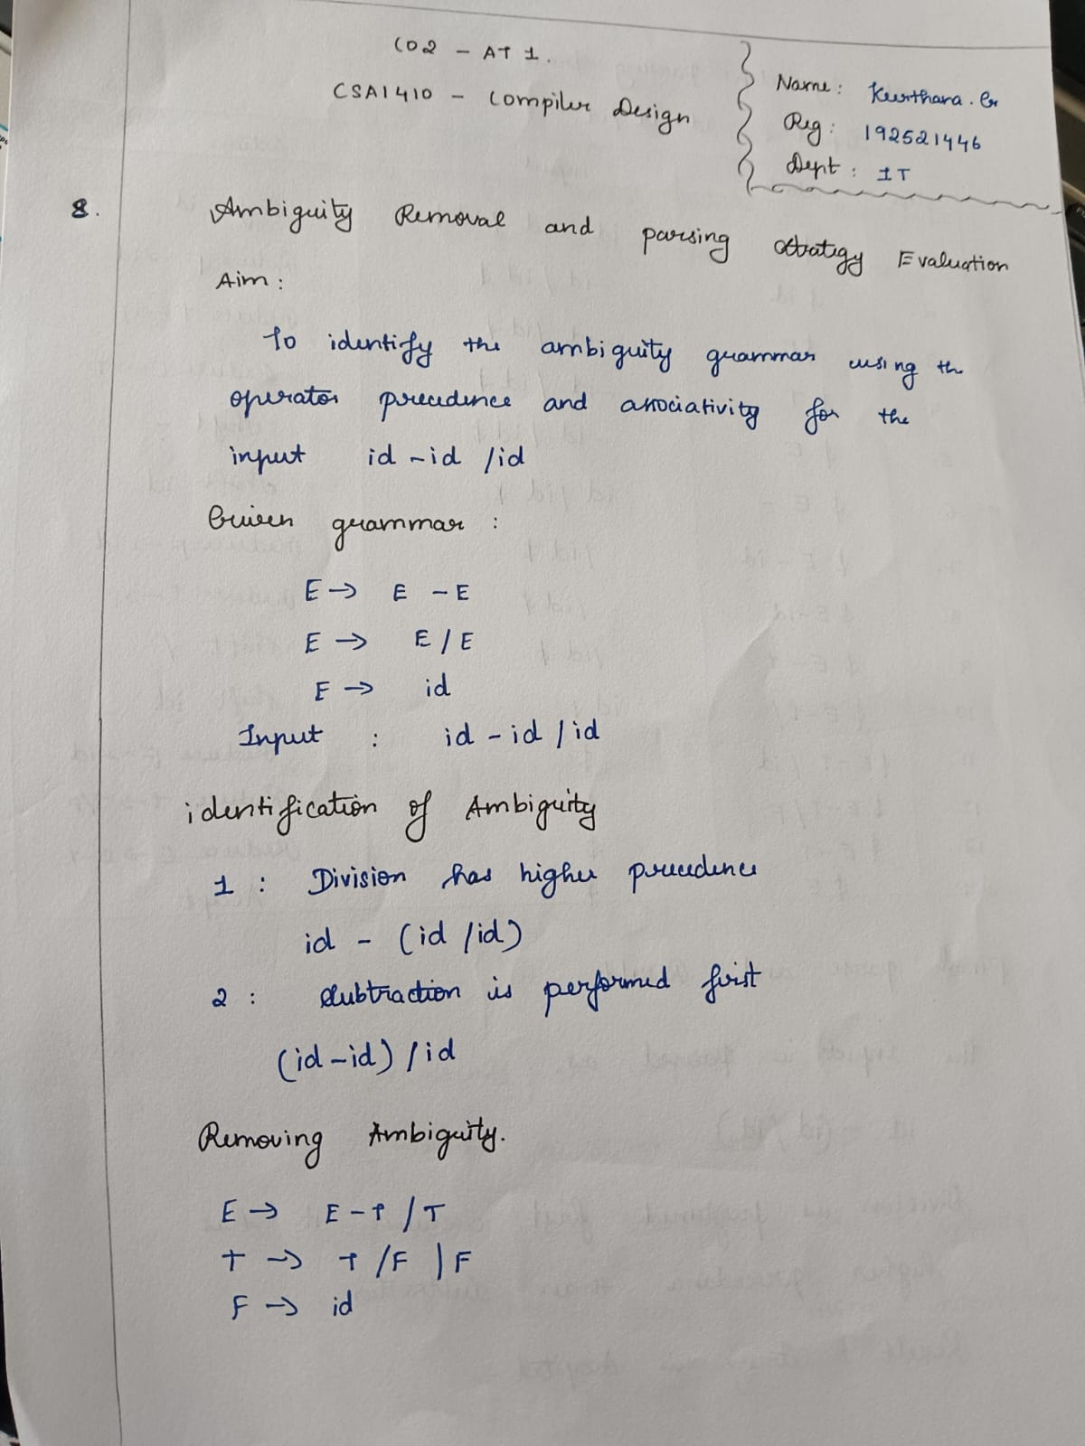

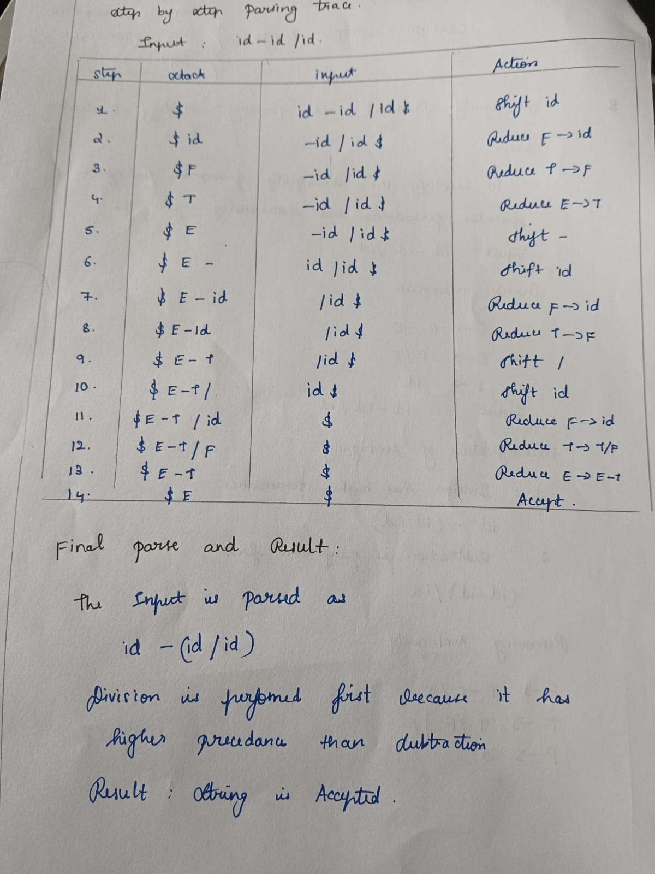

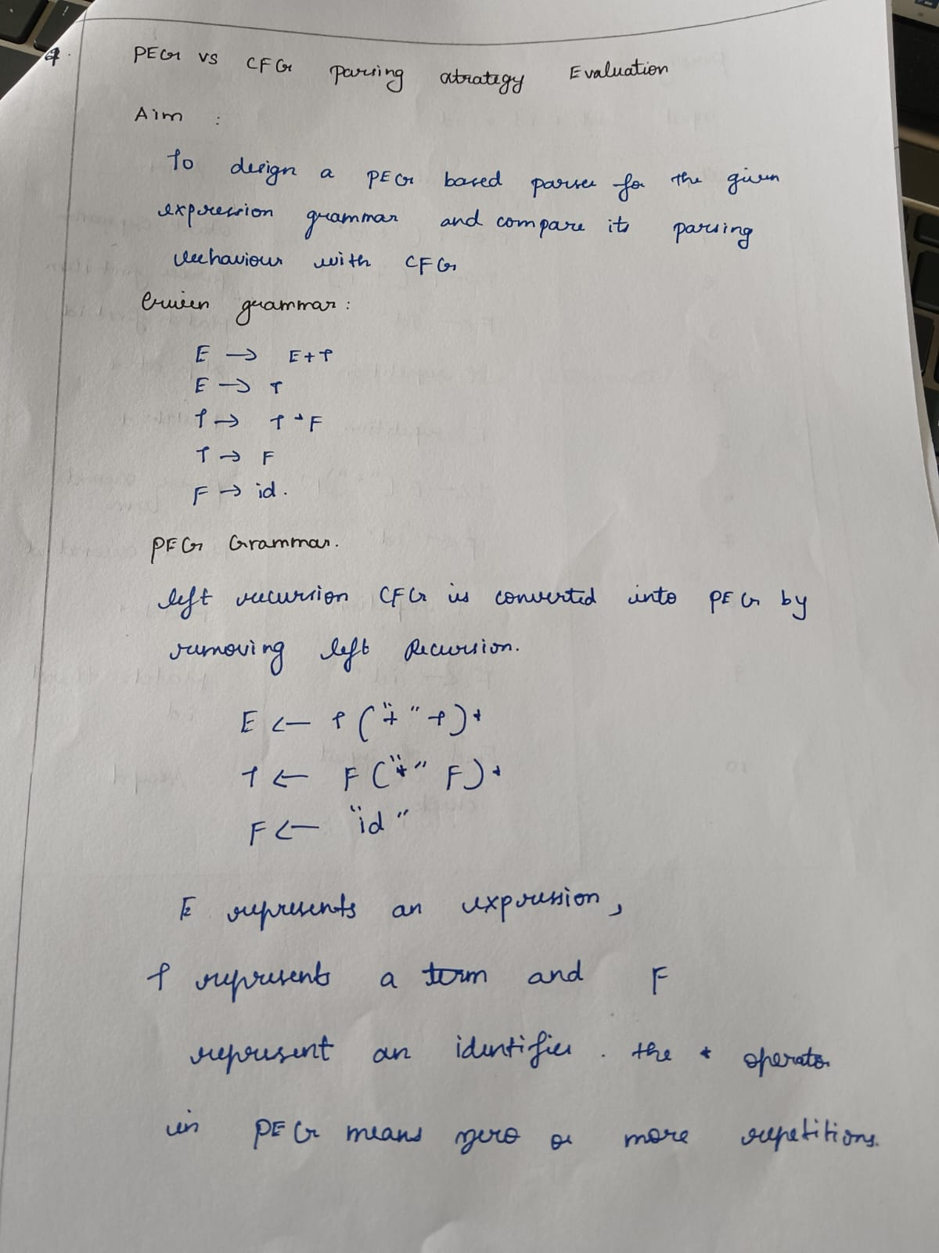

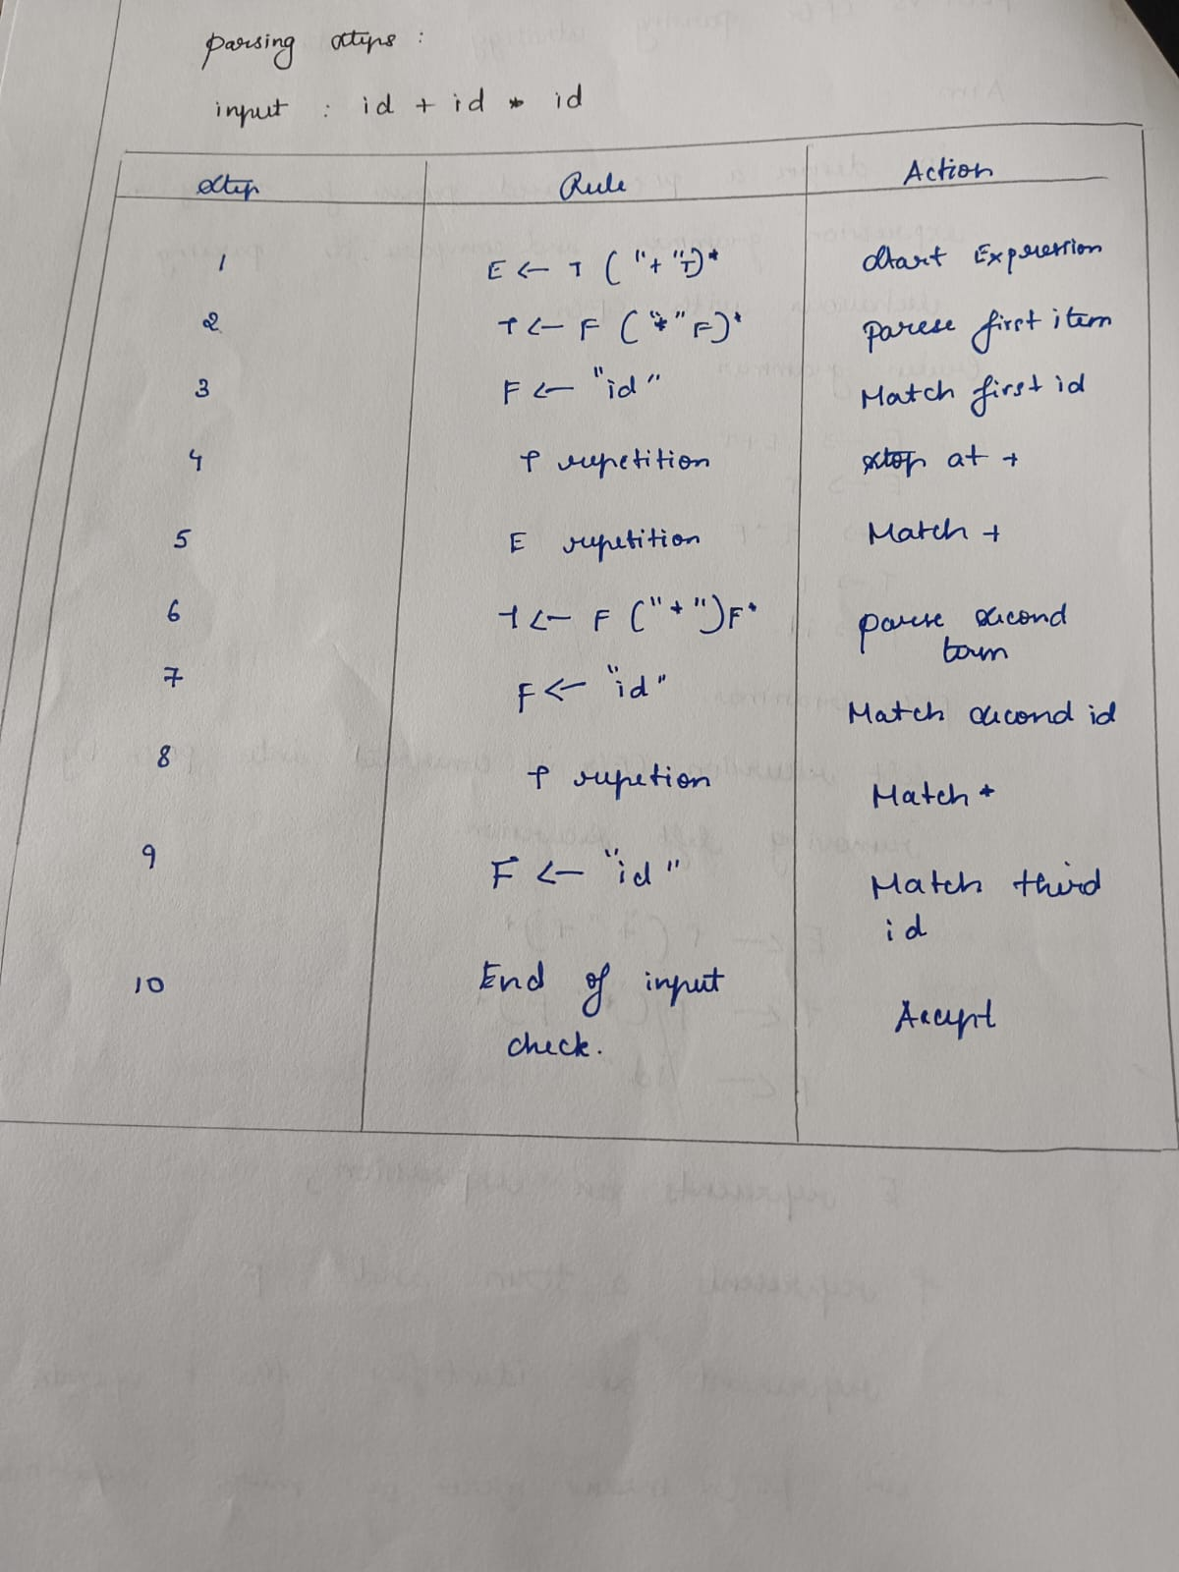

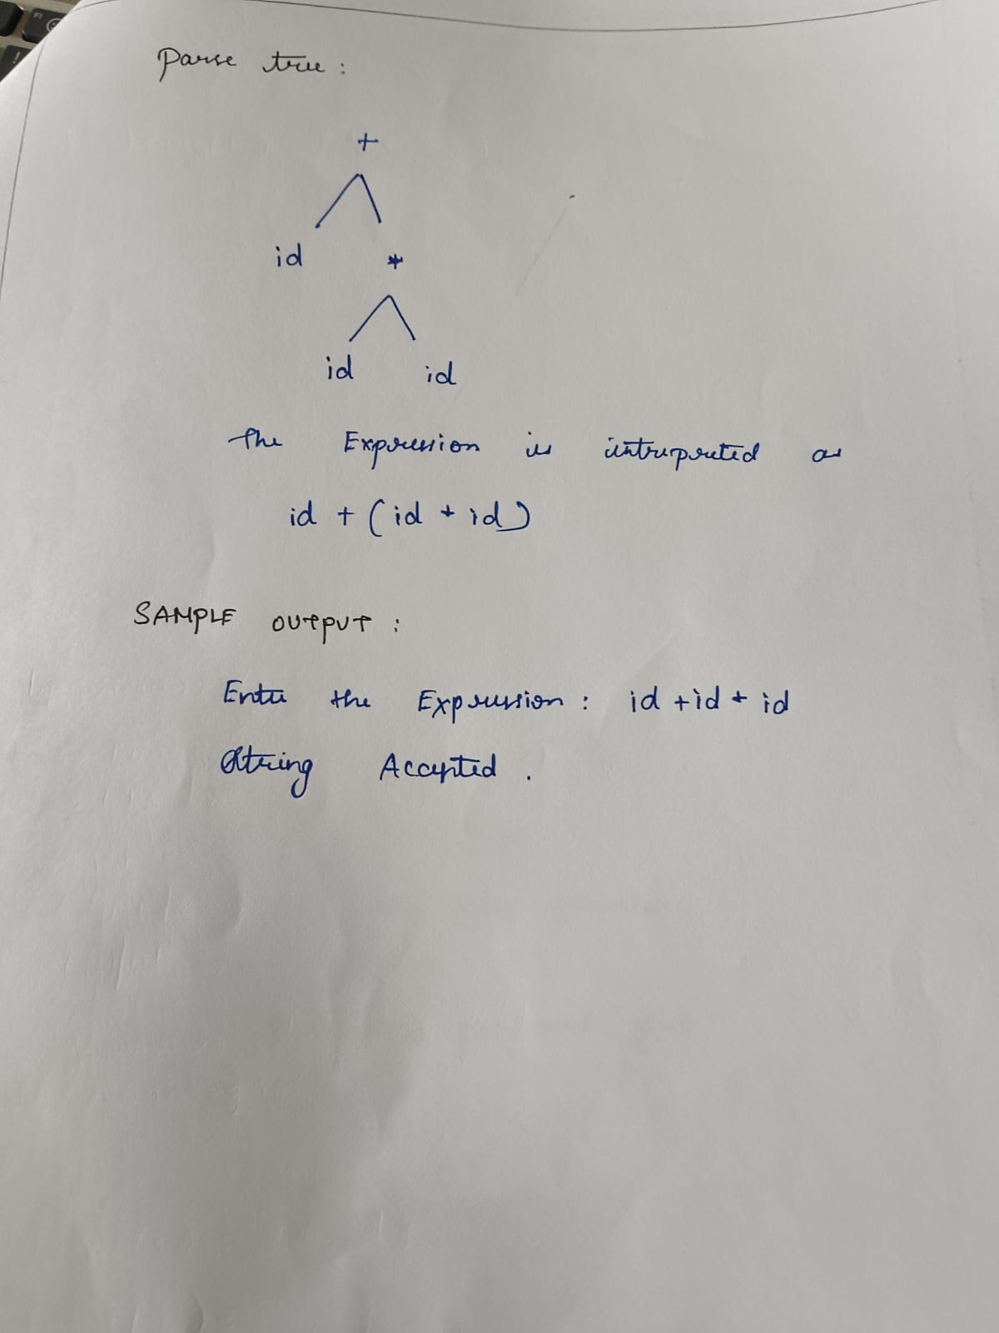

RUBRICS FOR CALCULATION:

Criteria | Weightage | Level 4 – Exemplary | Level 3 – Proficient | Level 2 – Developing | Level 1 – Beginning
Understanding of Concepts | 20 | Demonstrates thorough understanding and integrates multiple concepts effectively | Good understanding with proper integration of most concepts | Basic understanding with partial integration | Poor understanding with no integration
Design & Implementation | 25 | Well-designed solution with systematic and optimal implementation | Correct design with minor issues | Basic design with errors or inefficiencies | Incorrect or incomplete design
Parser/Algorithm Construction | 20 | Accurate construction of parser/algorithm with complete logic | Mostly correct construction with minor errors | Partial construction with missing logic | Incorrect or incomplete construction
Analysis & Validation | 15 | Insightful analysis with correct validation and justification | Good analysis with reasonable justification | Basic analysis with limited validation | Poor or incorrect analysis
Documentation & Presentation | 20 | Well-structured documentation with diagrams, steps, and clarity | Organized documentation with required details | Basic documentation with missing details | Poor or incomplete documentation

